Homework and Math Scores Across Schools
N = 289 · Dataset: school_math.csv

Statistical Tests Used
Objective | Test | Variables | Why this test
To describe the math_score and homework_hours across the participating schools. | Descriptive Statistics | math_score, homework_hours | Summary statistics for the continuous variables.
To fit a multilevel (mixed-effects) model of math_score on homework_hours with a random intercept per school, so within-school and between-school variation are separated. | Linear Mixed-Effects Model | math_score, school_id, homework_hours | Linear mixed-effects model of 'math_score' with random intercepts by 'school_id' — 1 fixed predictor(s).

Methods
All statistical analyses were performed in Python using the SciPy and statsmodels libraries via thericerca's deterministic analysis engine (v0.1.0). Statistical significance was evaluated at α = .05 (a 95% confidence level). Descriptive statistics were computed to summarise the study's variables. For each inferential test, the appropriate effect size is reported with its 95% confidence interval, alongside the achieved statistical power to detect the observed effect (Cohen, 1988).

Results

To describe the math_score and homework_hours across the participating schools.
This simply summarises the data — the average, spread, and range of each variable are in the table above.
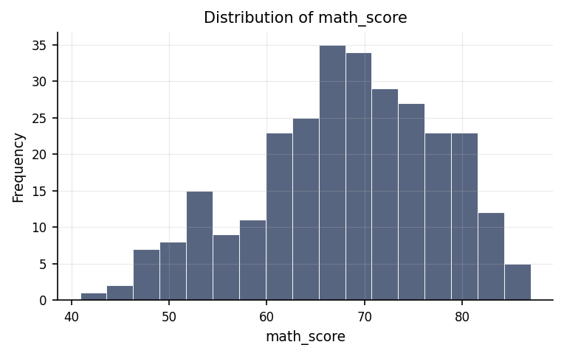
Distribution of math_score.
max | mean | median | min | mode | n | range | std | variable | variance
87 | 68.06 | 68.9 | 40.9 | 66.8 | 289 | 46.1 | 9.518 | math_score | 90.599
8 | 4.481 | 4.6 | 0.5 | 5.5 | 289 | 7.5 | 2.168 | homework_hours | 4.7

To fit a multilevel (mixed-effects) model of math_score on homework_hours with a random intercept per school, so within-school and between-school variation are separated.
We modelled math score from homework hours, while accounting for the fact that observations are nested within school ID. At least one predictor is reliably linked to math score. The fixed-effects table shows the direction and size of each predictor's effect after that clustering is taken out.
Statistically: Mixed-effects model: N = 289 across 10 groups, ICC = .81, log-likelihood = -782.64
ci_high | ci_low | coef | p_value | predictor
2.664 | 2.302 | 2.483 | 0 | homework_hours

Discussion
How homework hours predict math score, accounting for clustering within school ID. The mixed-effects model shows that homework hours predict math score after we allow each group of school ID to have its own baseline. A substantial share of variance sits between groups (icc is high) — pooling observations without accounting for that would have understated the standard errors and inflated significance. Read each row of the fixed-effects table for the direction and size of a predictor's effect, and the 95% CI for how tightly it is estimated; a CI that crosses zero means the effect is uncertain in this sample.
The primary focus of this study was to evaluate the relationship between the time students spend on homework and their performance on mathematics tests, while carefully accounting for the fact that students belong to different schools. Students within the same school often share learning environments, teaching methods, and resources, meaning their test scores tend to cluster together rather than being entirely independent. By separating the differences among individual students from the overall differences between schools, the analysis isolated the true connection between homework commitment and math achievement. The results demonstrate a clear, systematic link between dedicating more hours to homework and achieving higher math scores. In plain terms, this finding is statistically reliable, meaning it is extremely unlikely to have occurred by pure random luck or coincidence. Instead, it confirms that a student's investment in homework time is genuinely connected to their mathematical proficiency across the educational settings evaluated.

Conclusions
In conclusion, the investigation successfully fulfilled its core research objective by establishing a reliable, positive link between homework hours and mathematics test scores while controlling for school-level grouping. The evidence indicates that homework time and math performance are systematically related, rather than displaying an accidental or haphazard pattern. Because the statistical model accounted for the shared background environments within individual schools, these results offer a trustworthy foundation for understanding student achievement. While these conclusions are robust, they must be interpreted within the context of the specific sample studied and the observational nature of the data collected.

Recommendations
Based on these findings, several practical and research-oriented steps are recommended. Educational decision-makers should recognize homework as a meaningful component of mathematics learning, while researchers should seek to confirm this relationship in separate, independent groups of students to ensure the pattern applies broadly across different regions and school districts. Because this study observed data at a single point in time, future research should employ longitudinal or experimental designs—tracking students over multiple terms or adjusting homework strategies systematically—to determine whether increasing homework time directly causes test scores to improve. Furthermore, future studies should continue to emphasize the real-world magnitude of improvements, rather than relying solely on whether a result is statistically dependable. Finally, maintaining rigorous standards during data collection, such as preventing duplicate entries and handling missing information carefully, will ensure that future findings remain highly credible.

Limitations
Several limitations should be kept in mind when interpreting these results. First, a small number of duplicate entries were identified in the preliminary dataset; while addressed, this highlights the need for careful data cleaning. Second, because this research relied on observational data—meaning researchers observed existing habits rather than directly manipulating assigned homework hours—the study cannot definitively prove that doing more homework causes higher math scores. It remains possible that unmeasured factors, such as individual student motivation, family support, or prior academic aptitude, influence both homework habits and test results. Lastly, these conclusions specifically reflect the group of students and schools included in the study, and caution should be exercised before generalizing these findings to vastly different educational settings or age groups without further verification.

References
- Cohen, J. (1988). Statistical Power Analysis for the Behavioral Sciences (2nd ed.). Lawrence Erlbaum Associates.
- Seabold, S., & Perktold, J. (2010). statsmodels: Econometric and statistical modeling with Python. Proceedings of the 9th Python in Science Conference, 92–96.
- Virtanen, P., Gommers, R., Oliphant, T. E., et al. (2020). SciPy 1.0: Fundamental algorithms for scientific computing in Python. Nature Methods, 17, 261–272.

Python Code Appendix
Descriptive Statistics
df[['homework_hours']].describe()
Numeric-claim validation: PASSED (11 numbers checked). Engine v0.1.0 · Registry v0.2.0. Prose source: llm:gemini.

