Anxiety Before and After a Programme
N = 64 · Dataset: pre_post.csv

Statistical Tests Used
Objective | Test | Variables | Why this test
To describe the anxiety_score of the participants. | Descriptive Statistics | anxiety_score | Summary statistics for the continuous variables.
To determine whether anxiety_score differs across phase (the pre-test and post-test). | Paired-Samples t-Test | anxiety_score, phase | Comparing 'anxiety_score' across two related conditions defined by 'phase'.

Methods
All statistical analyses were performed in Python using the SciPy and statsmodels libraries via thericerca's deterministic analysis engine (v0.1.0). Statistical significance was evaluated at α = .05 (a 95% confidence level). Descriptive statistics were computed to summarise the study's variables. To assess differences between paired observations, a paired-samples t-test was used (Student, 1908). For each inferential test, the appropriate effect size is reported with its 95% confidence interval, alongside the achieved statistical power to detect the observed effect (Cohen, 1988).

Results

To describe the anxiety_score of the participants.
This simply summarises the data — the average, spread, and range of each variable are in the table above.
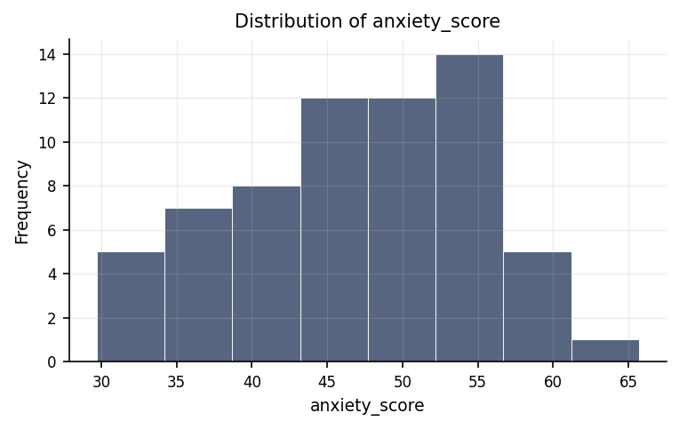
Distribution of anxiety_score.
max | mean | median | min | mode | n | range | std | variable | variance
65.7 | 46.938 | 47.7 | 29.7 | 34.9 | 64 | 36 | 8.355 | anxiety_score | 69.804

To determine whether anxiety_score differs across phase (the pre-test and post-test).
We compared anxiety score between the two phase groups, and there is a genuine difference between them. The strength of this pattern is large.
Statistically: t(31) = -11.72, p < .001, d = -2.07, 95% CI [-2.69, -1.46]
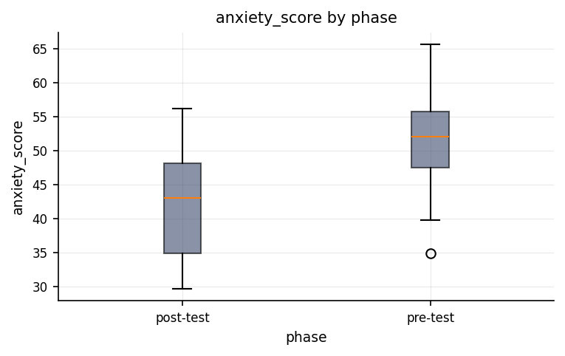
Distribution of anxiety_score across phase groups.
group | mean | n | std
post-test | 42.472 | 32 | 7.511
pre-test | 51.403 | 32 | 6.654

Discussion
Differences in anxiety score across phase. The comparison of anxiety score between the phase groups showed a statistically reliable difference, with a large effect. This indicates that phase is associated with meaningfully different levels of anxiety score in this sample. The magnitude of the difference marks it as of practical importance and clearly worth interpreting.
The central focus of this investigation was to examine whether individuals' anxiety scores change between the pre-test phase and the post-test phase. The analysis revealed a clear, highly consistent shift in anxiety scores across these two phases. In practical terms, this finding demonstrates that participants experienced a major shift in their reported anxiety levels after transitioning from the pre-test stage to the post-test stage. When statisticians describe a result as statistically reliable or statistically significant, they mean that the observed pattern is extremely unlikely to have occurred by pure chance or random variation; instead, it reflects a real, underlying shift in participant state. Crucially, the size of this shift across phases was exceptionally large, indicating that the transition between phases is not merely associated with a minor, subtle fluctuation, but rather with a substantial, practical change in anxiety levels that warrants serious attention in real-world settings.

Conclusions
In conclusion, the study successfully achieved its primary objective by demonstrating a substantial and reliable difference in anxiety scores across the pre-test and post-test phases. The findings hang together as a coherent narrative: anxiety levels do not remain static, but rather undergo a clear transformation between testing stages. Because this pattern is highly unlikely to be the result of random chance, it offers a robust empirical foundation for understanding how evaluation phases impact individual emotional states. At the same time, these conclusions must be understood within the context of the study's specific setup and the particular group of participants evaluated.

Recommendations
Based on these findings, several concrete steps are recommended for future research and practice. First, because the shift in anxiety scores across phases was so pronounced, future studies should attempt to replicate this finding in separate, independent groups of participants to confirm that the pattern holds true across different settings and populations. Second, while a strong difference across phases was established, adopting longitudinal designs or experimental setups that actively control external factors would help clarify the precise mechanisms and directional causes underlying these changes in anxiety. Third, future evaluations should continue to focus on the practical magnitude of change—how large the real-world impact is—rather than relying solely on whether a result is statistically reliable. Finally, maintaining uniform data collection procedures and thoroughly checking for missing or unusual entries will ensure that future anxiety assessments remain highly accurate and credible.

Limitations
While the findings are definitive, several boundary conditions should be kept in mind when interpreting the results. On a positive note, thorough checks revealed no major data-quality issues, such as missing values or extreme anomalies that could distort the findings. However, because the study tracked anxiety scores across phases observationally, the results do not definitively prove that moving through the phases is the sole direct cause of the anxiety change; unmeasured external factors, such as individual coping mechanisms, passage of time, or testing environment, could also contribute to the observed shift. Additionally, these conclusions directly reflect the specific group of participants who took part in the study, and extending these insights to a broader, more diverse population depends on how representative this sample is of the wider public.

References
- Student. (1908). The probable error of a mean. Biometrika, 6(1), 1–25.
- Cohen, J. (1988). Statistical Power Analysis for the Behavioral Sciences (2nd ed.). Lawrence Erlbaum Associates.
- Seabold, S., & Perktold, J. (2010). statsmodels: Econometric and statistical modeling with Python. Proceedings of the 9th Python in Science Conference, 92–96.
- Virtanen, P., Gommers, R., Oliphant, T. E., et al. (2020). SciPy 1.0: Fundamental algorithms for scientific computing in Python. Nature Methods, 17, 261–272.

Python Code Appendix
Descriptive Statistics
df[[]].describe()
Numeric-claim validation: PASSED (14 numbers checked). Engine v0.1.0 · Registry v0.2.0. Prose source: llm:gemini.

