Descriptive-Correlational Survey: Study Habits and Academic Performance
N = 180 · Dataset: study_habits_survey.csv

Statistical Tests Used
Objective | Test | Variables | Why this test
To describe the profile of the respondents in terms of sex and year_level. | Frequency & Percentage Distribution | sex, year_level | Frequency and percentage distribution for the categorical variables.
To describe the study habits of the respondents in terms of sets_a_study_schedule, takes_organized_notes, reviews_lessons_daily, studies_in_a_quiet_place, and avoids_distractions. | Frequency & Percentage Distribution | sets_a_study_schedule, takes_organized_notes, reviews_lessons_daily, studies_in_a_quiet_place, avoids_distractions | Frequency and percentage distribution for the categorical variables.
To describe the study habits of the respondents in terms of sets_a_study_schedule, takes_organized_notes, reviews_lessons_daily, studies_in_a_quiet_place, and avoids_distractions. | Weighted Mean with Verbal Interpretation | sets_a_study_schedule, takes_organized_notes, reviews_lessons_daily, studies_in_a_quiet_place, avoids_distractions | Weighted mean and verbal interpretation for the 5 items on a common rating scale.
To determine the relationship between study_habits_score and general_weighted_average. | Spearman Rank Correlation | study_habits_score, general_weighted_average
To determine whether general_weighted_average differs between the sex groups. | Independent-Samples t-Test | general_weighted_average, sex | Comparing mean general weighted average between the two independent groups of sex.
Some assumptions came out close to the cut-off — the plots below let you see the shape of the data behind each verdict.
Spearman Rank Correlation — To determine the relationship between study_habits_score and general_weighted_average.
Normality of study_habits_score (Shapiro-Wilk) — not met, p = 0.0051 · checked for Pearson Correlation; this is why Spearman Rank Correlation was used instead
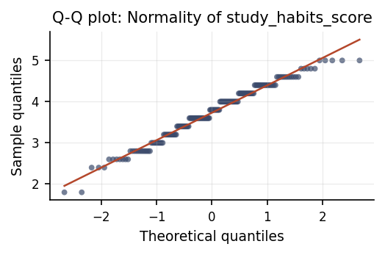
Points close to the reference line = the data are normally distributed; systematic curvature at the tails = departure from normality.

Methods
All statistical analyses were performed in Python using the SciPy and statsmodels libraries via thericerca's deterministic analysis engine (v0.1.0). Statistical significance was evaluated at α = .05 (a 95% confidence level). Descriptive statistics were computed to summarise the study's variables. To assess the central tendency of responses to each item on the rating scale, with the resulting means interpreted against equal-width verbal bands spanning the scale, a weighted mean with verbal interpretation was used (Likert, 1932). To assess monotonic associations between variables, a Spearman rank-order correlation was used (Spearman, 1904). To assess differences between two independent groups, an independent-samples t-test was used (Student, 1908). For each inferential test, the appropriate effect size is reported with its 95% confidence interval, alongside the achieved statistical power to detect the observed effect (Cohen, 1988).

Results

To describe the profile of the respondents in terms of sex and year_level.
This shows how the responses are distributed: how many people fall into each category, and what share of the total that is.
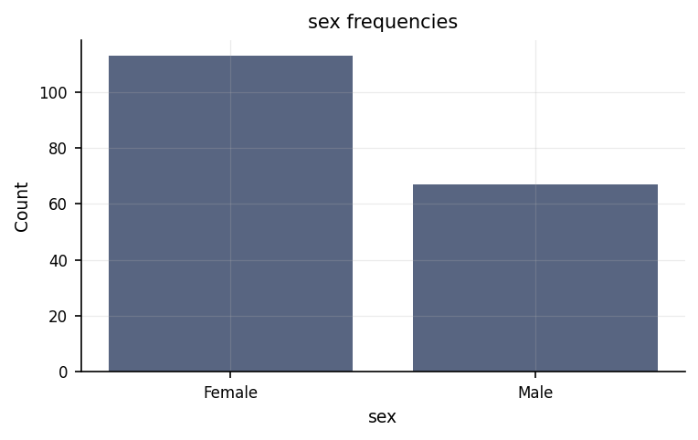
Frequency of each sex category.
count | percent | value | variable
113 | 62.778 | Female | sex
67 | 37.222 | Male | sex
51 | 28.333 | 2 | year_level
50 | 27.778 | 3 | year_level
47 | 26.111 | 1 | year_level
32 | 17.778 | 4 | year_level

To describe the study habits of the respondents in terms of sets_a_study_schedule, takes_organized_notes, reviews_lessons_daily, studies_in_a_quiet_place, and avoids_distractions.
This shows how the responses are distributed: how many people fall into each category, and what share of the total that is.
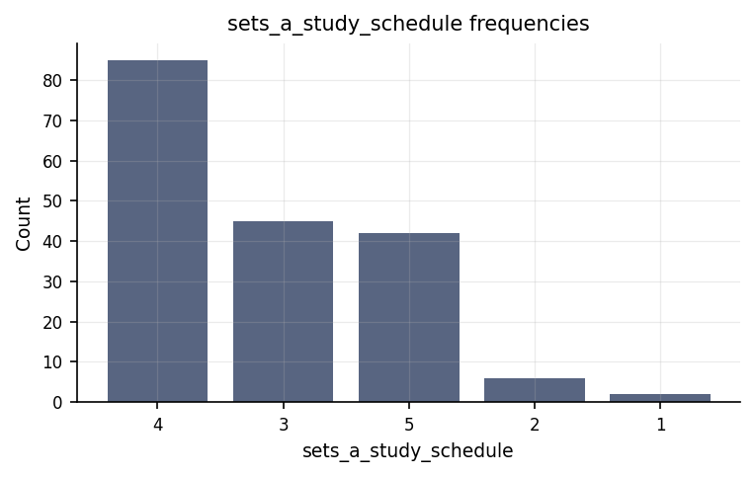
Frequency of each sets_a_study_schedule category.
count | percent | value | variable
85 | 47.222 | 4 | sets_a_study_schedule
45 | 25 | 3 | sets_a_study_schedule
42 | 23.333 | 5 | sets_a_study_schedule
6 | 3.333 | 2 | sets_a_study_schedule
2 | 1.111 | 1 | sets_a_study_schedule
70 | 38.889 | 4 | takes_organized_notes
58 | 32.222 | 5 | takes_organized_notes
45 | 25 | 3 | takes_organized_notes
7 | 3.889 | 2 | takes_organized_notes
79 | 43.889 | 3 | reviews_lessons_daily
64 | 35.556 | 4 | reviews_lessons_daily
19 | 10.556 | 2 | reviews_lessons_daily
16 | 8.889 | 5 | reviews_lessons_daily
2 | 1.111 | 1 | reviews_lessons_daily
81 | 45 | 4 | studies_in_a_quiet_place
52 | 28.889 | 5 | studies_in_a_quiet_place
41 | 22.778 | 3 | studies_in_a_quiet_place
6 | 3.333 | 2 | studies_in_a_quiet_place
79 | 43.889 | 3 | avoids_distractions
58 | 32.222 | 4 | avoids_distractions
24 | 13.333 | 2 | avoids_distractions
18 | 10 | 5 | avoids_distractions
1 | 0.556 | 1 | avoids_distractions

To describe the study habits of the respondents in terms of sets_a_study_schedule, takes_organized_notes, reviews_lessons_daily, studies_in_a_quiet_place, and avoids_distractions.
Each item's average rating is shown with the verbal label it falls under, so the table reads the way a rating scale is normally reported. The median sits beside each average as a check: where the two disagree, responses are lopsided and the average alone would overstate the consensus.
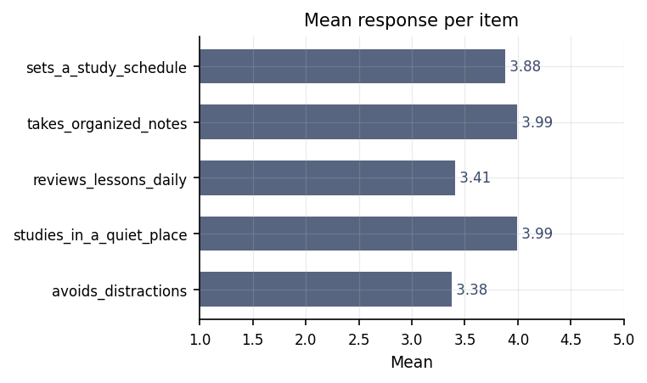
Mean response for each item, plotted on the rating scale's own range.
interpretation | item | median | n | rank | sd | weighted_mean
Agree | sets_a_study_schedule | 4 | 180 | 3 | 0.841 | 3.883
Agree | takes_organized_notes | 4 | 180 | 1 | 0.855 | 3.994
Agree | reviews_lessons_daily | 3 | 180 | 4 | 0.837 | 3.406
Agree | studies_in_a_quiet_place | 4 | 180 | 2 | 0.808 | 3.994
Neutral | avoids_distractions | 3 | 180 | 5 | 0.86 | 3.378
⚠ The interpretation bands assume a 1-5 scale. State the instrument's scale if it differs.
⚠ Weighted means treat the rating scale as equal-interval, which is the standard convention for summarising Likert items but is a descriptive summary, not a statistical test. The median is reported beside each mean as the measure that does not require that assumption.

To determine the relationship between study_habits_score and general_weighted_average.
We looked at whether study habits score and general weighted average move together. They do — as one goes up, the other tends to go up too. The strength of this pattern is large.
Statistically: ρ = .68, p < .001, achieved power = 1.00
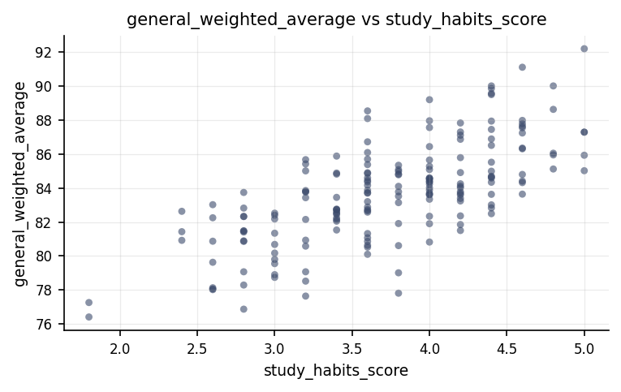
Relationship between study_habits_score and general_weighted_average.
⚠ Spearman Rank Correlation was used instead of the Pearson Correlation because the latter's assumption(s) were not met (Normality of study_habits_score (Shapiro-Wilk)).

To determine whether general_weighted_average differs between the sex groups.
We compared general weighted average between the two sex groups. They came out about the same — the small difference we see could easily be down to chance rather than a real sex effect.
Statistically: t(178) = 0.67, p = .503, d = 0.10, 95% CI [-0.20, 0.41], achieved power = 0.10
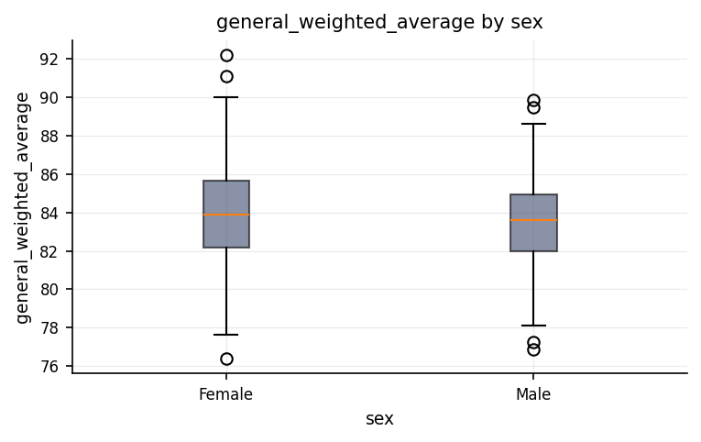
Distribution of general_weighted_average across sex groups.
group | mean | n | std
Female | 83.823 | 113 | 2.964
Male | 83.52 | 67 | 2.849

Discussion
How the respondents rated the 5 items on the scale. Respondents expressed the highest level of agreement with the statement 'takes organized notes' and the lowest agreement with 'avoids distractions'. Across the five individual survey items, student ratings varied between 'Neutral' and 'Agree', demonstrating that individual habits differ enough to warrant examining each item separately rather than relying solely on a single combined score. Overall, the typical response across the scale aligned with 'Agree', as reflected by the weighted mean and supported by the median, which confirmed that responses were distributed smoothly without extreme skewness overstating student consensus.
The relationship between study habits score and general weighted average. Higher study habits score was consistently linked with a higher general weighted average, establishing a statistically reliable positive association. Students who maintained stronger study routines systematically achieved better marks, reflecting a large and meaningful overlap between their daily study practices and overall academic performance. While this strong correlation indicates that study practices and grades move together reliably rather than by random chance, it does not prove that study habits directly cause higher academic standing.
Differences in general weighted average across sex. Female and male participants achieved comparable academic performance, as general weighted average did not show a statistically reliable difference across sex. The tiny difference observed between the groups confirms that the gap is negligible in practical terms, demonstrating that sex does not separate or explain student achievement in these data.
Students demonstrated a clear alignment between their self-reported learning routines and overall academic standing, whereas comparisons between demographic groups revealed no meaningful divergence in performance. Specifically, the relationship between study habits score and general weighted average provided statistically reliable evidence that effective study practices go hand in hand with higher academic achievement. In contrast, the comparison of general weighted average across sex yielded no statistically reliable difference, indicating that male and female students performed at comparable levels in this sample. Because the study produced statistically reliable findings for behavioral factors but not for demographic categories, interpretation should focus heavily on the substantial role of study habits while treating the lack of sex differences as an absence of detectable effect rather than absolute proof of parity.

Conclusions
Academic behaviors emerged as the primary factor associated with student success, while demographic background offered no distinct explanatory pattern. The statistically reliable link between study habits score and general weighted average confirms that daily learning routines are closely tied to academic marks, making this relationship a strong candidate for future interventions and research. Conversely, general weighted average showed no statistically reliable difference across sex, indicating that sex should not be assumed to influence academic outcomes in this context. Maintaining a clear distinction between confirmed behavioral associations and non-significant demographic comparisons ensures that conclusions remain grounded in reliable empirical evidence.

Recommendations
Future research should aim to confirm the statistically reliable link between study habits score and general weighted average by studying independent student groups over time. To move beyond observational patterns, researchers should implement longitudinal or experimental studies capable of testing whether improving study routines directly causes higher academic performance. Additionally, the non-significant comparison of general weighted average across sex should be re-evaluated in larger, more representative samples to determine if subtle differences exist that this sample could not detect. Maintaining consistent data collection methods, reporting effect sizes and confidence intervals alongside statistical significance, and carefully screening for missing values will help ensure future results remain trustworthy.

Limitations
Observational design constraints restrict the ability to draw direct causal conclusions from the findings. Although the relationship between study habits score and general weighted average is statistically reliable, this association does not establish that superior study habits directly cause higher marks, as unmeasured personal or environmental factors could influence both variables. Furthermore, because these patterns reflect this specific group of participants, extending the findings to broader student populations depends on how closely this sample mirrors the wider group. Finally, while no major data quality issues were identified, self-reported survey measures can introduce subjective reporting biases.

References
- Likert, R. (1932). A technique for the measurement of attitudes. Archives of Psychology, 22(140), 1–55.
- Spearman, C. (1904). The proof and measurement of association between two things. American Journal of Psychology, 15(1), 72–101.
- Student. (1908). The probable error of a mean. Biometrika, 6(1), 1–25.
- Cohen, J. (1988). Statistical Power Analysis for the Behavioral Sciences (2nd ed.). Lawrence Erlbaum Associates.
- Seabold, S., & Perktold, J. (2010). statsmodels: Econometric and statistical modeling with Python. Proceedings of the 9th Python in Science Conference, 92–96.
- Virtanen, P., Gommers, R., Oliphant, T. E., et al. (2020). SciPy 1.0: Fundamental algorithms for scientific computing in Python. Nature Methods, 17, 261–272.

Python Code Appendix
Frequency & Percentage Distribution
df['sex'].value_counts(normalize=True)
Weighted Mean with Verbal Interpretation
items = df[['sets_a_study_schedule', 'takes_organized_notes', 'reviews_lessons_daily', 'studies_in_a_quiet_place', 'avoids_distractions']]
means = items.mean() # weighted mean per item
width = (hi - lo) / len(labels) # equal-width interpretation bands
interpretation = means.map(lambda m: labels[min(int((m - lo) / width), len(labels) - 1)])
Spearman Rank Correlation
r, p = stats.spearmanr(df['study_habits_score'], df['general_weighted_average'])
Independent-Samples t-Test
a, b = groups(df, 'general_weighted_average', 'sex')
t, p = stats.ttest_ind(a, b, equal_var=True)
Numeric-claim validation: PASSED (20 numbers checked). Engine v0.1.0 · Registry v0.3.0. Prose source: llm:gemini.

